Progress Report

**Github Setup**

Signed up to Github and made a public account on Sunny95DMU with the repository CTEC3905_Web_Development_Assignment.

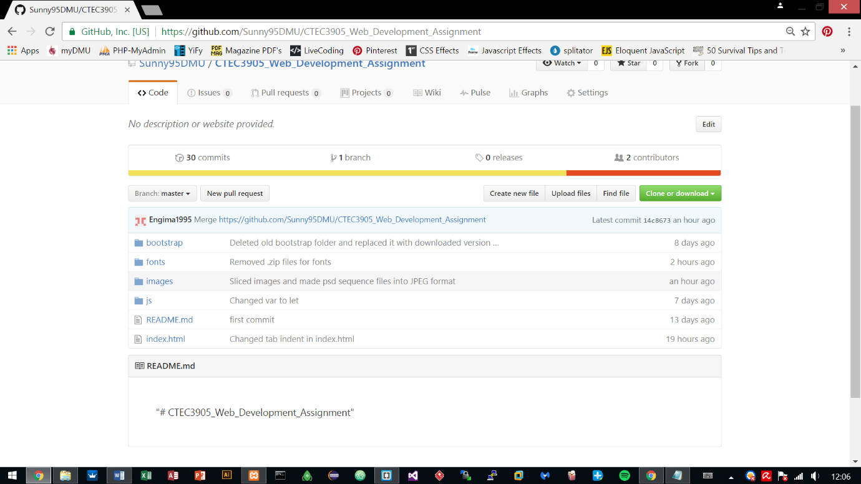

Installed .git local repository for pulling and pushing local work on to the Github repository.

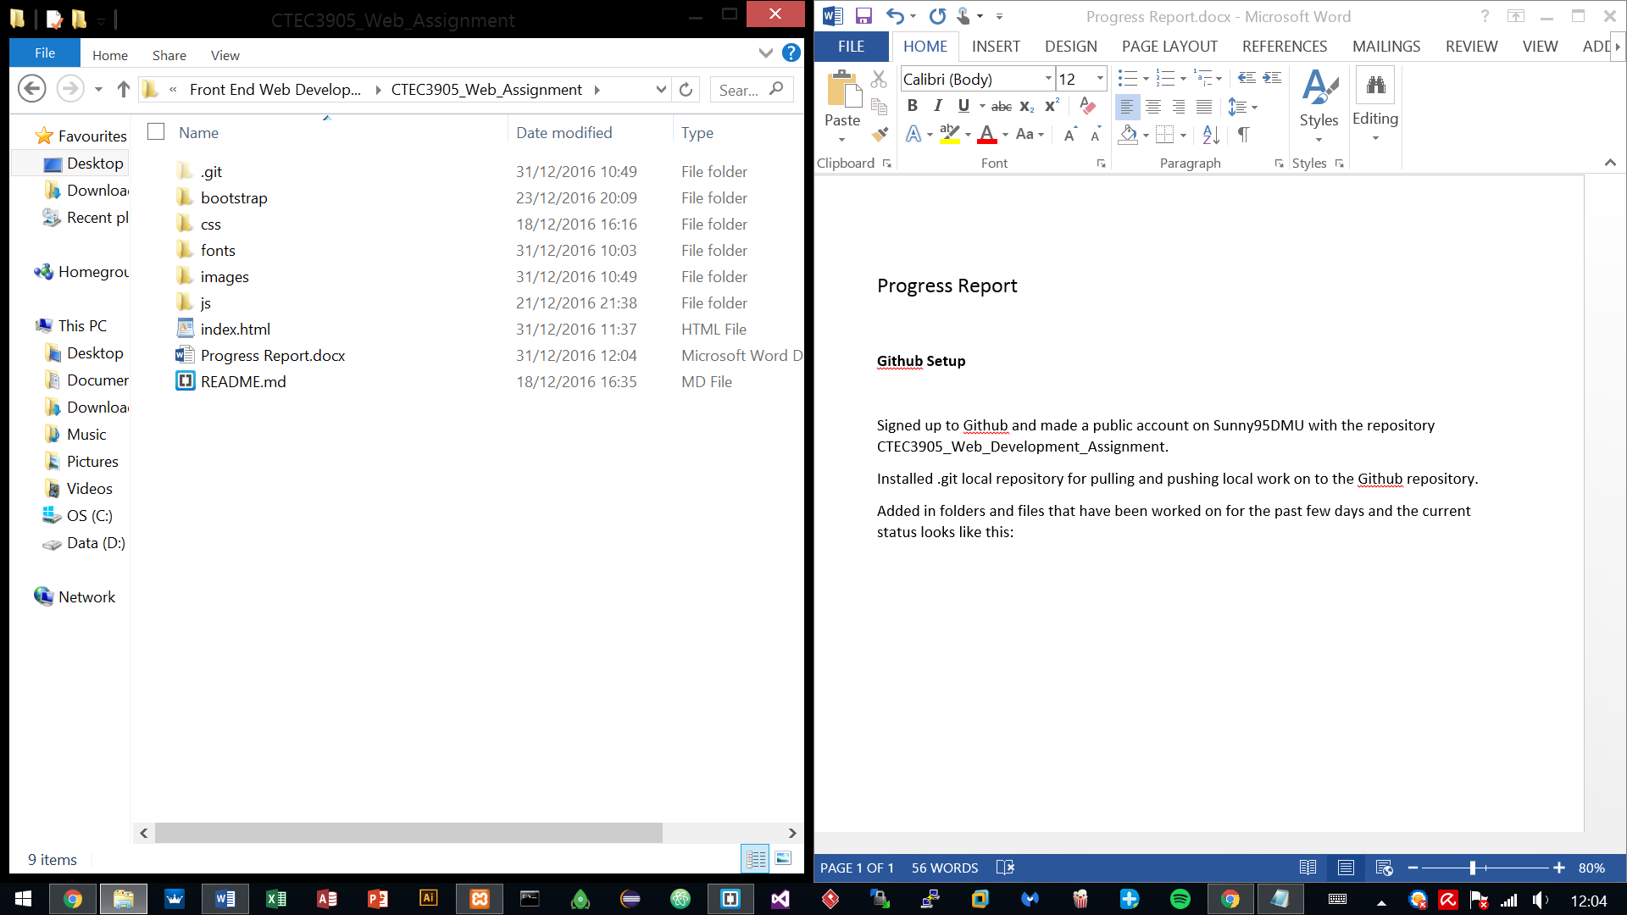Added in folders and files that have been worked on for the past few days and the current status looks like this:

**Fetching Flickr data with JSON**

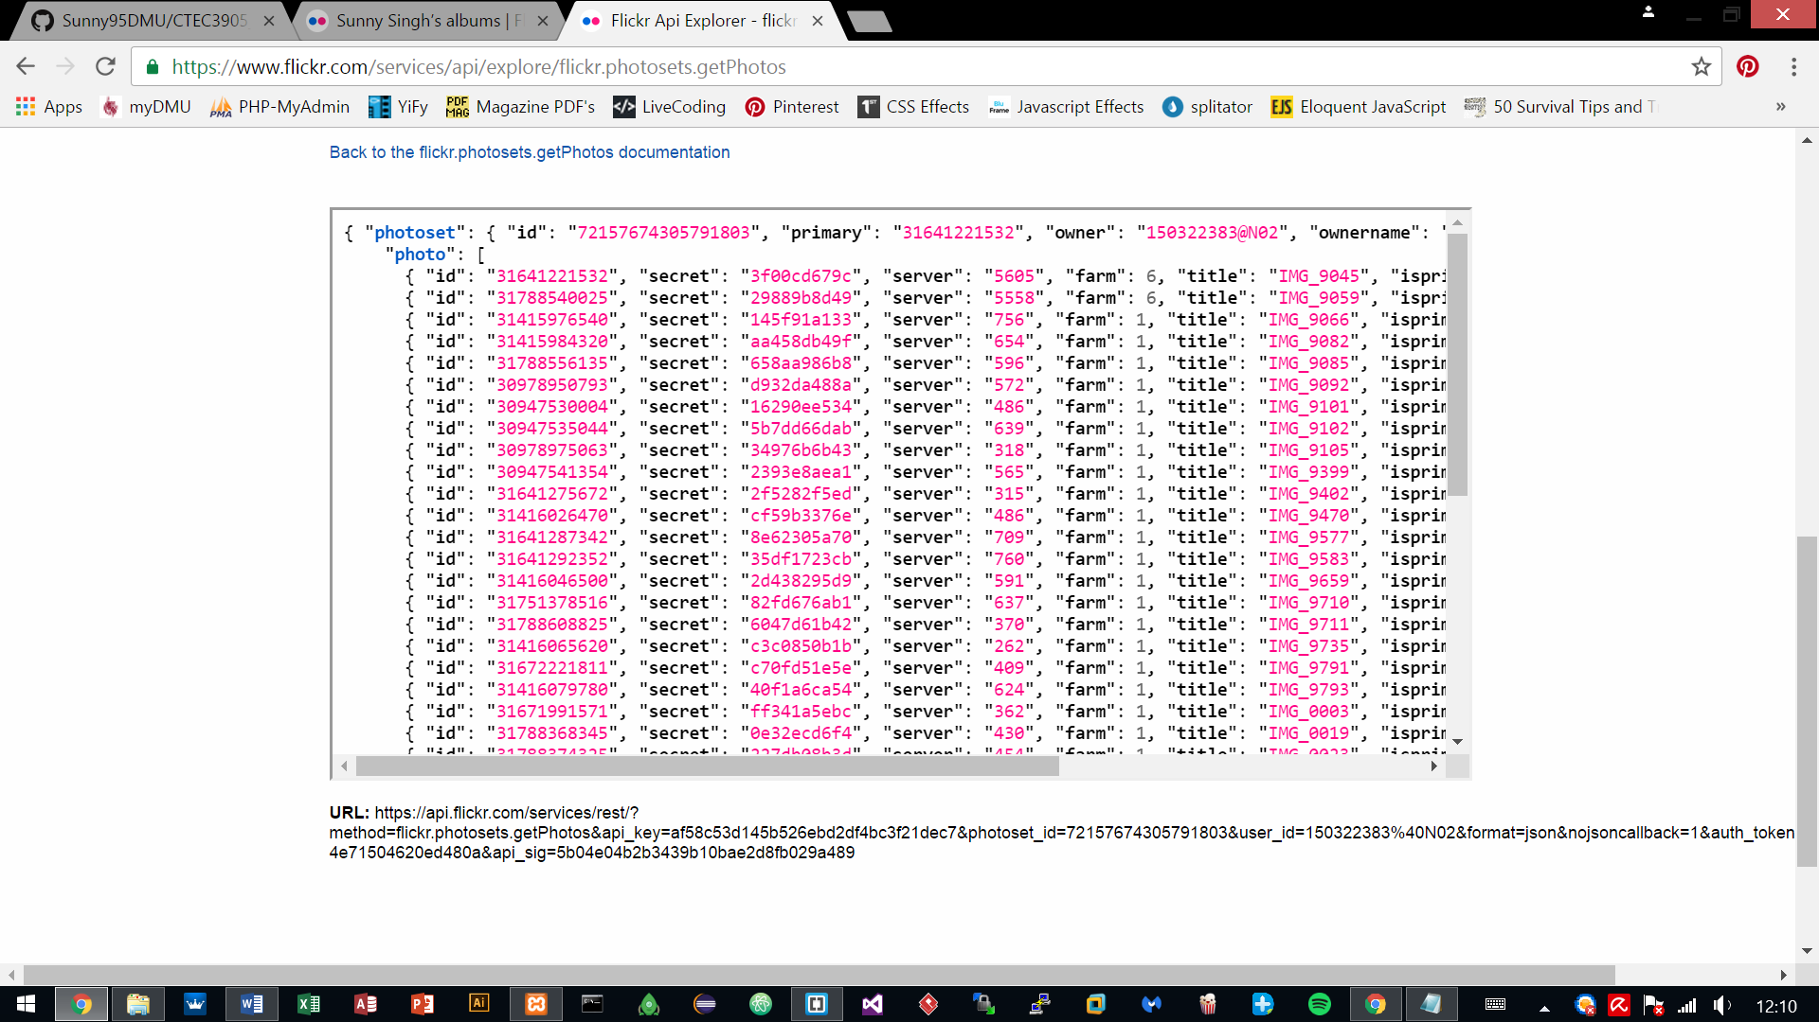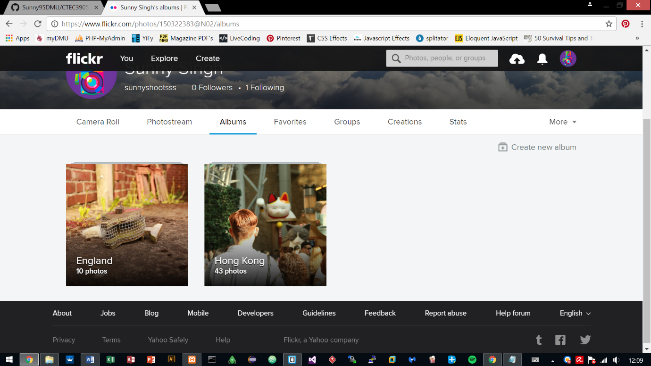Uploaded images to Flickr and used Flickr API to retrieve those uploaded images via JSON, for future use with the development of the site.

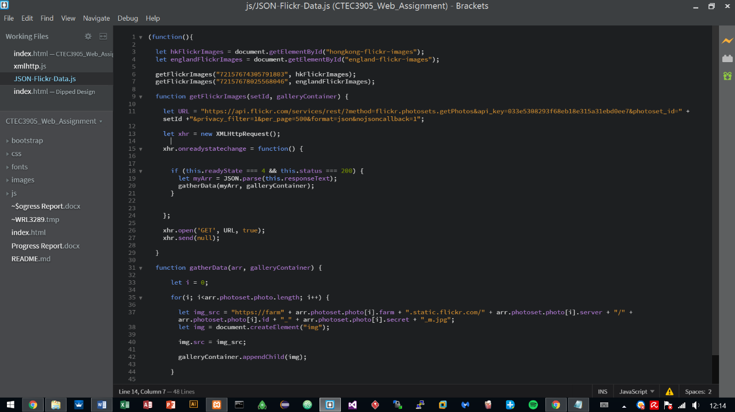Used the API key provided by the Flickr site and used it with JSON for connecting to the server, which in return gave an array of the uploaded images.

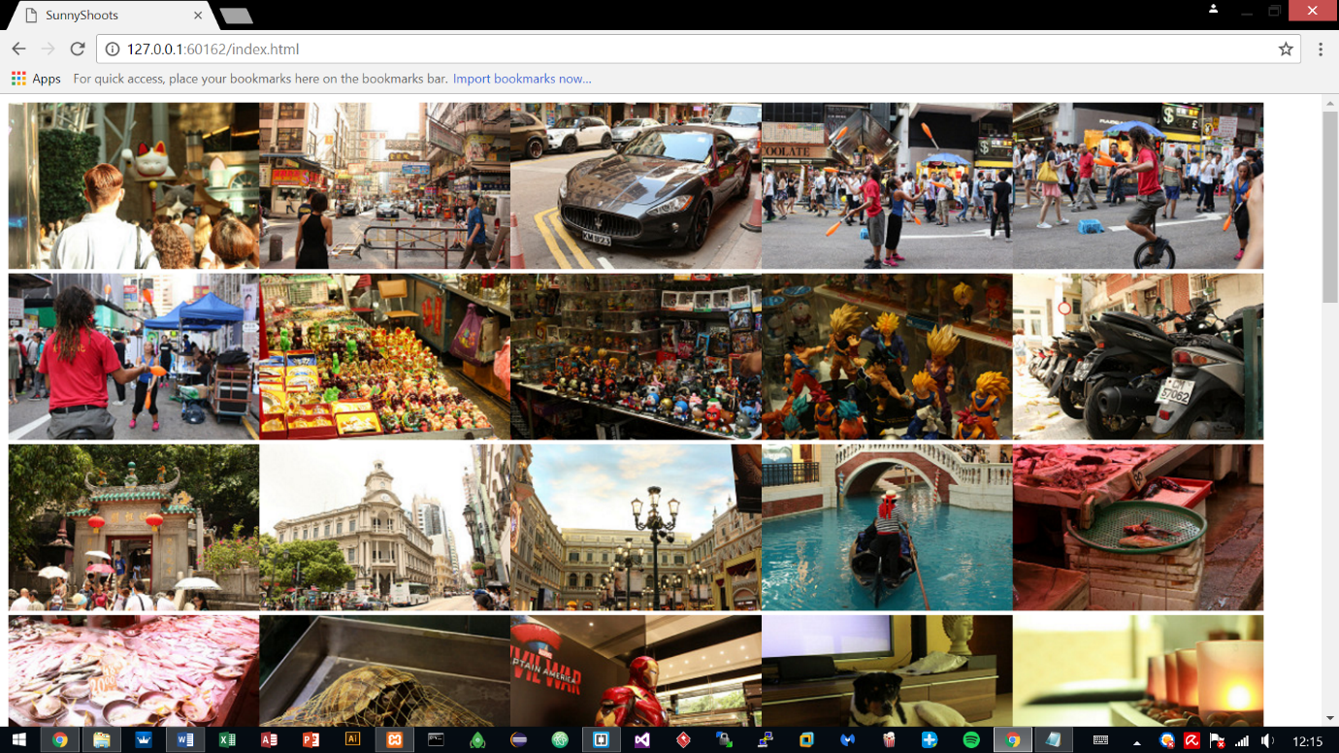

**Created Interface design**

After testing the JSON and the result being successful, it was time to move on to the interface design.

The website is based on a photography portfolio hence why testing the images was important.

The website was done in Photoshop and took 2 days to finish the interface, altogether 8 hours were put into it.

**Sequence 1 – Index Page**

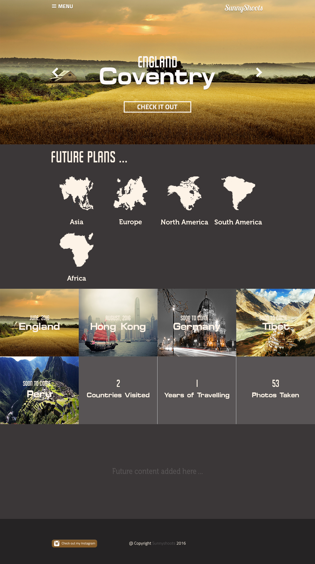

**Sequence 2 – Opening Menu**

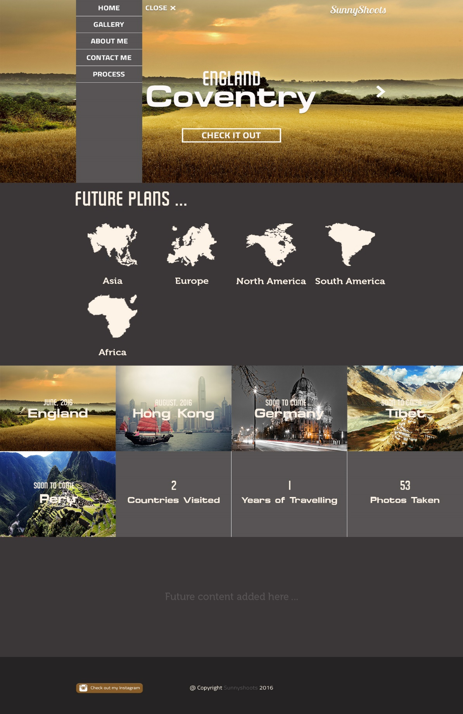

**Sequence 3 – Gallery Tab**

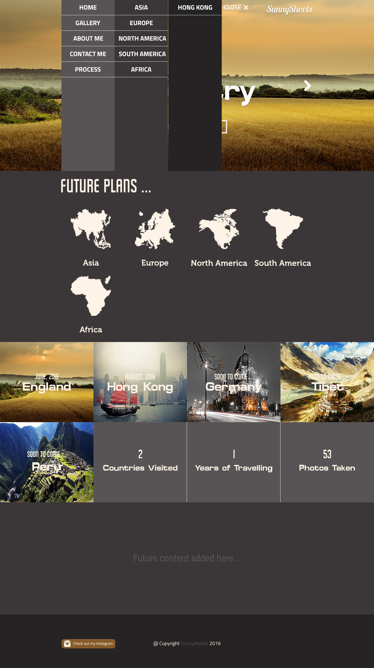

**Sequence 4 – Gallery Page**

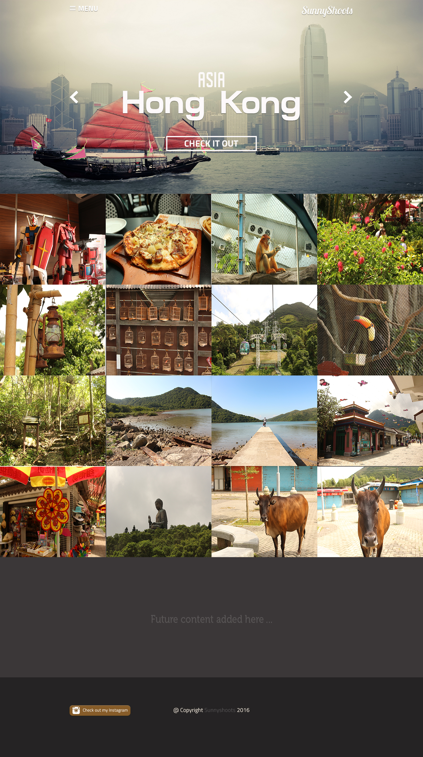

**Sequence 5 – About Me**

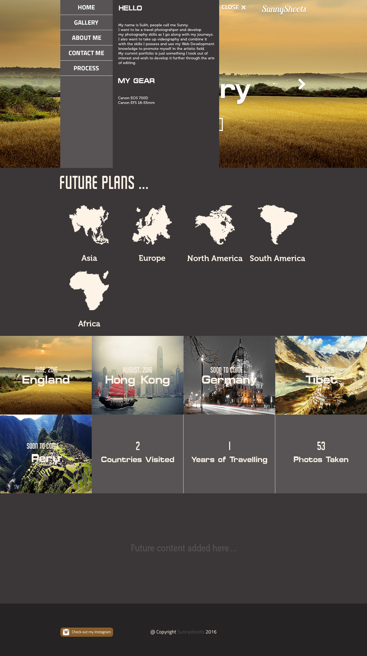

**Sequence 6 – Contact Me**

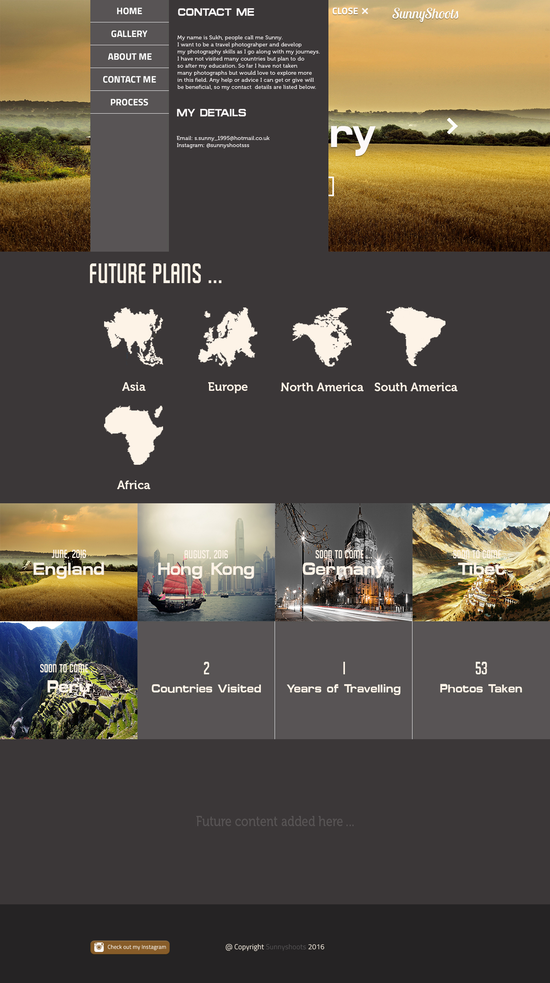

**Started working on index.html**

Index.html is the page that is loaded first. Most likely there are only going to be 3 pages altogether for this demo site: Home page and the Gallery Pages.

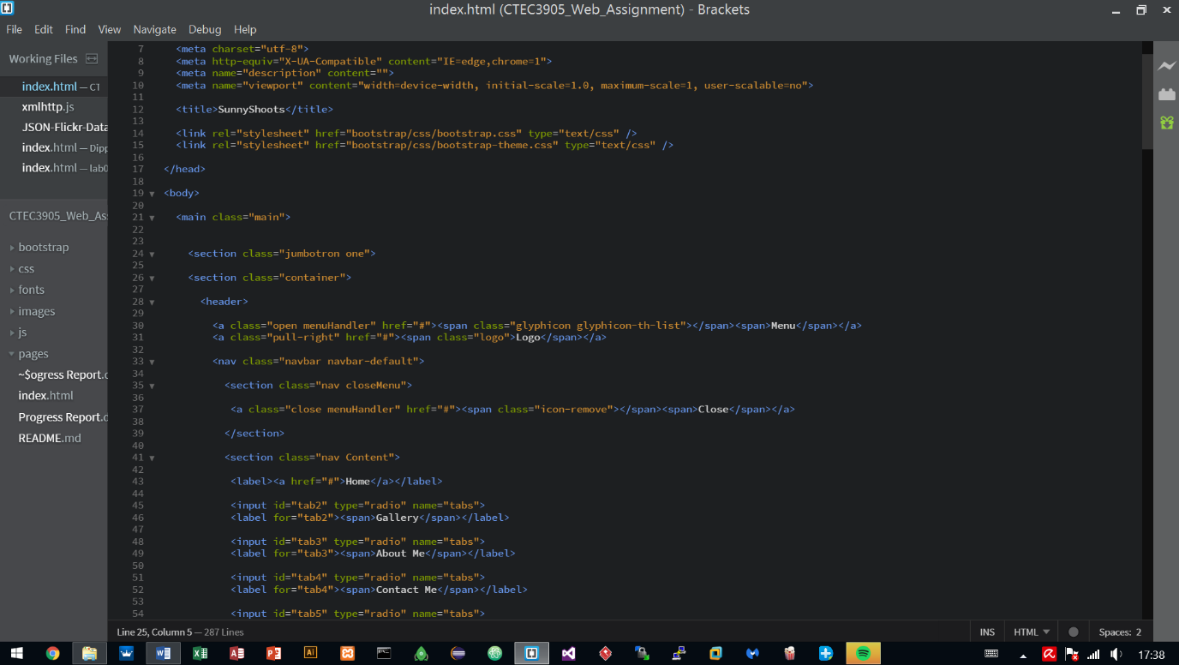Currently started structuring the index.html page using Bootstrap a quick framework to develop the site. The reason for this is, Bootstrap has been utilised before in other projects and has proven to work well as well as providing quick results so other areas could be looked at earlier on such as using animations and JavaScript to handle parts of the site.

